**Foodie Soodie User Guide**

## Introduction

Welcome to Foodie Soodie, your go-to online food ordering application. This guide will help you navigate through the app's features and functionalities, making your food ordering experience seamless and enjoyable.

## Table of Contents

1. Getting Started
   * Account Registration
   * Logging In
2. Navigating the Home Page
   * Searching for Restaurants
   * Viewing Restaurant Details
3. Placing an Order
   * Selecting Items
   * Reviewing the Cart
   * Checkout Process
4. Account Management
   * Viewing Order History
   * Updating Profile Information
5. Admin Features
   * Managing Users
   * Viewing and Managing Orders
   * Adding and Updating Menu Items

## 1. Getting Started

### Account Registration

1. Open the Foodie Soodie application.

1. Click on the "Register" link located at the top right corner of the homepage.

1. Fill in your personal details, including your first name, last name, email address, and password.
2. Click the "Register" button to create your account.

### Logging In

1. Open the Foodie Soodie application.

1. Click on the "Login" link located at the top right corner of the homepage.
2. Enter your registered email address and password.

1. Click the "Login" button to access your account.

## 2. Navigating the Home Page

### Searching for Restaurants

1. Use the search bar at the top of the homepage to find restaurants by name or cuisine.
2. 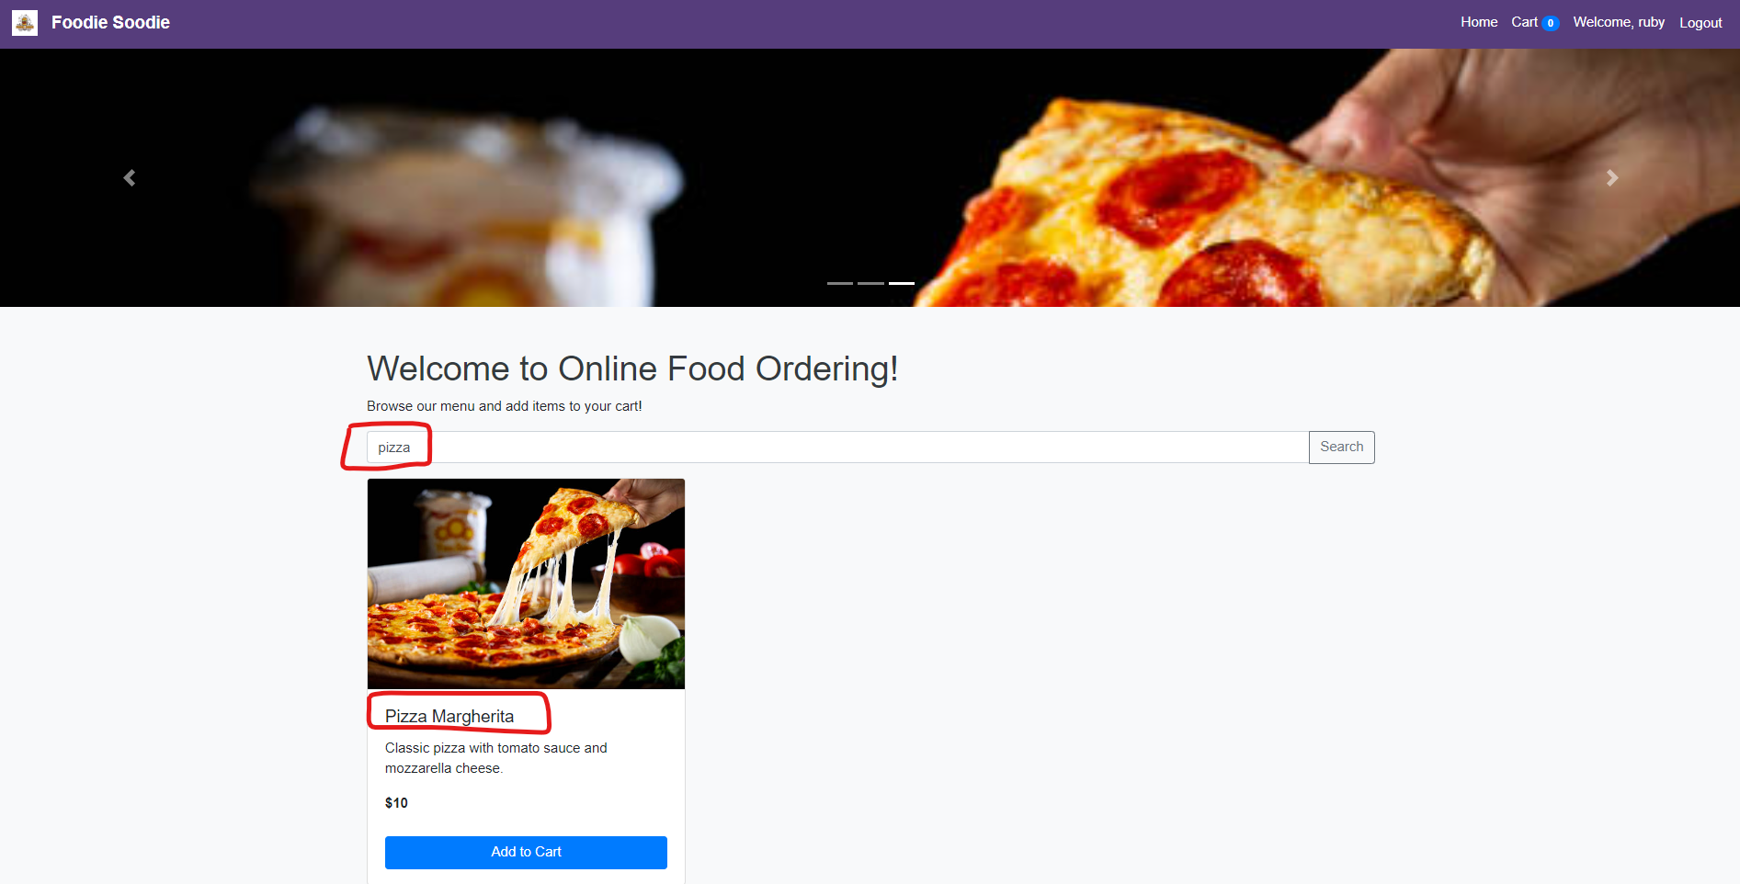

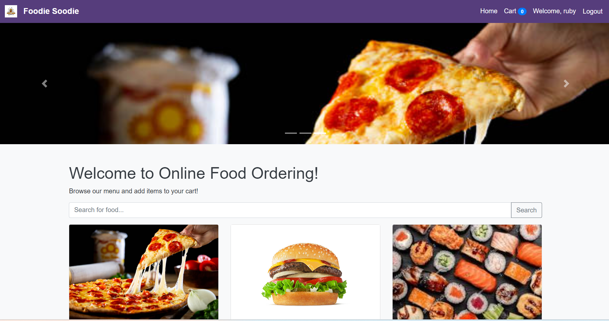

### Viewing Restaurant Details

1. Click on a restaurant's name or image to view its menu and details.
2. Review the restaurant's ratings, location, and available menu items.

## 3. Placing an Order

### Selecting Items

1. Browse the restaurant’s menu.
2. Click on the items you wish to order.
3. Select the quantity and any specific preferences or add-ons.
4. Click the "Add to Cart" button to add the item to your cart.

### Reviewing the Cart

1. Click on the cart icon at the top right corner of the page to review your selected items.
2. Adjust quantities or remove items if necessary.

### Checkout Process

1. Click the "Checkout" button in the cart view.

1. Enter your delivery address and payment details.

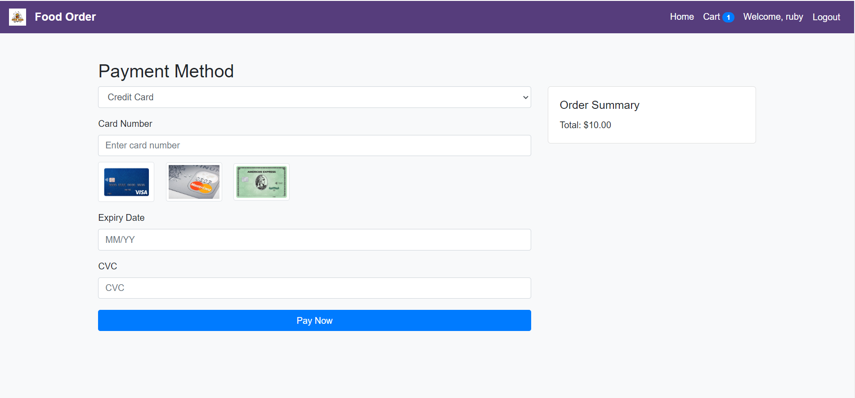

1. Review your order and click "Place Order" to complete the process.
2. You will receive a confirmation email with your order details.

## 5. Admin Features

### Managing Users

1. Log in with an admin account.

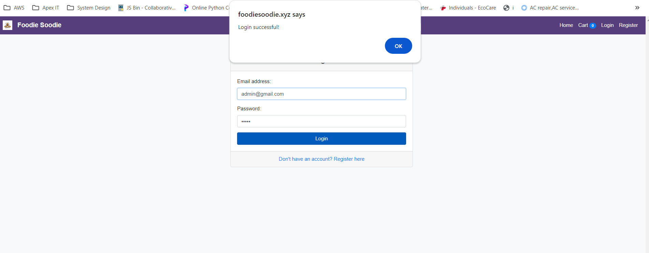

1. Click on "Admin Dashboard" from the navigation menu.

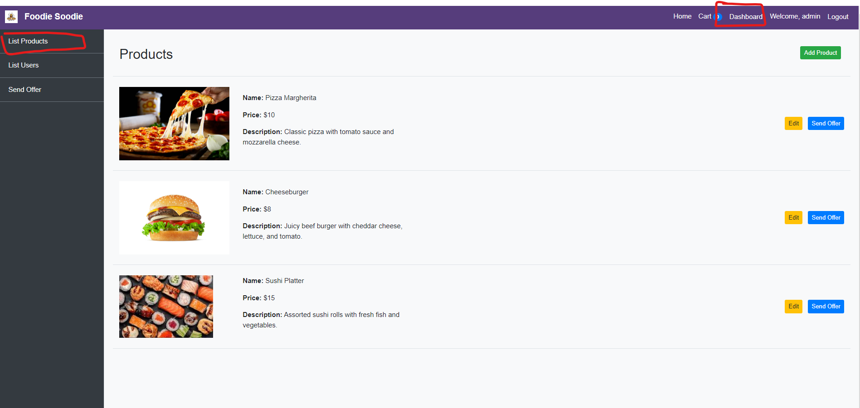

1. Select "Manage Users" to view, edit, or delete user accounts.

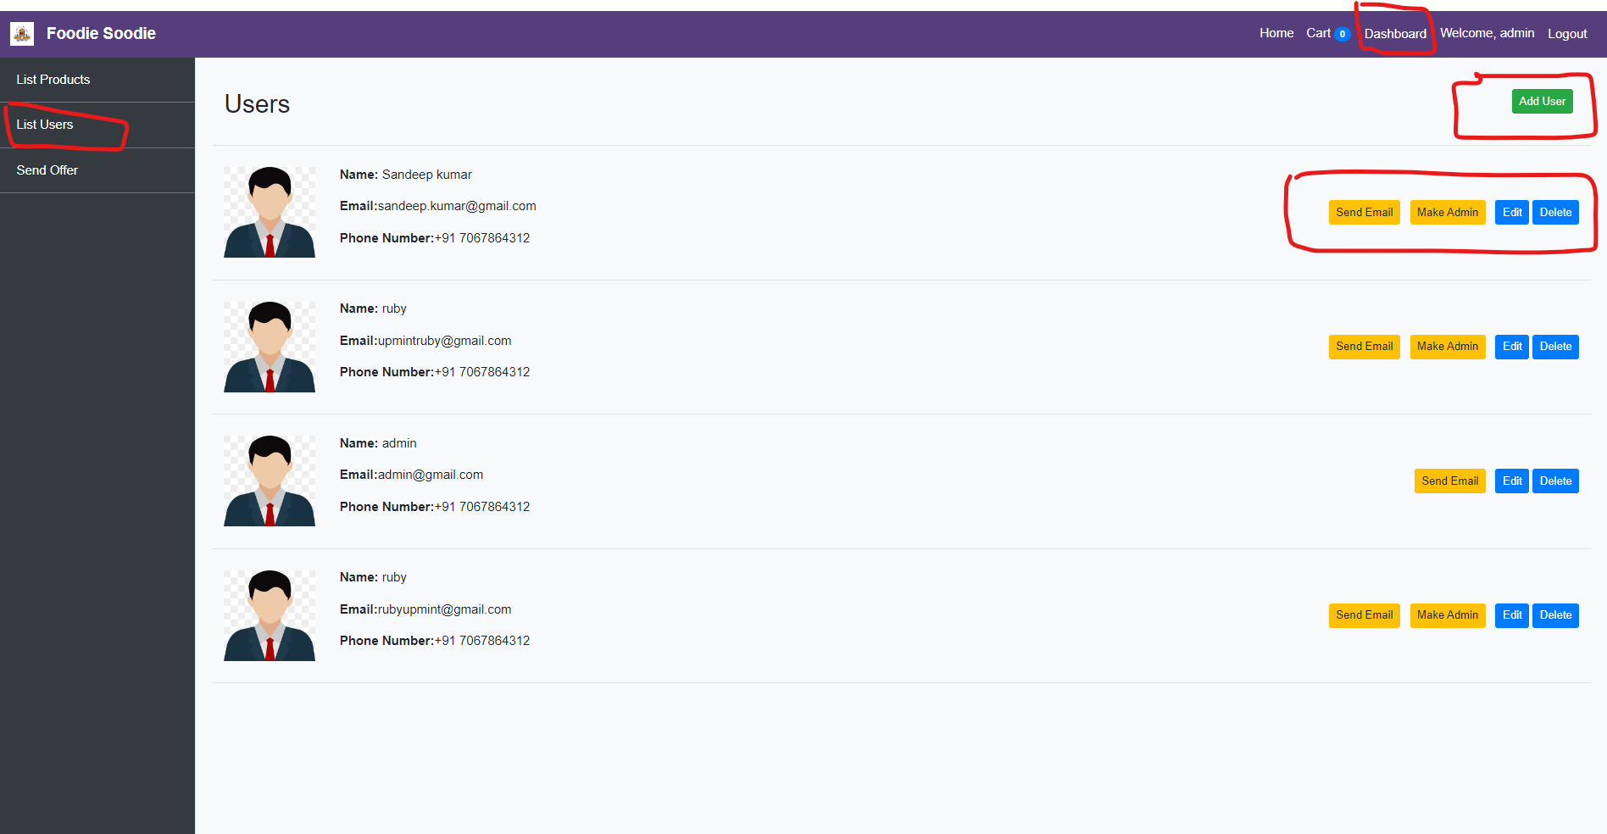

### Viewing and Managing Orders

1. In the Admin Dashboard, select "Manage Orders."

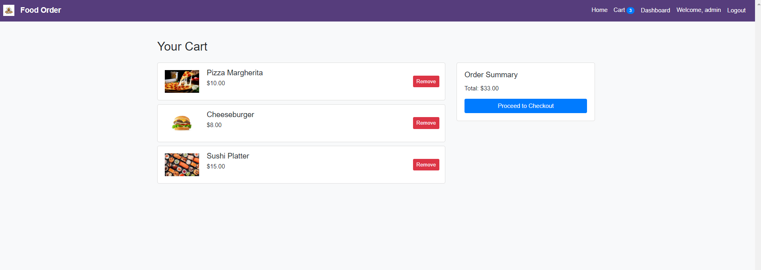

1. View all orders, update their statuses, or contact customers if needed.

### Adding and Updating Menu Items

1. In the Admin Dashboard, select "Manage Menu."
2. Click "Add Item" to add new menu items or select existing items to update their details.

Thank you for using Foodie Soodie! We hope this guide helps you enjoy our app to the fullest. If you have any questions or need further assistance, feel free to reach out to me.